SAP MDK Development and Deployment to Cloud Foundry

- Download Asset Manager 2210 metadata from SAP Software Downloads.
Import the zip file to Business Application Studio and Rename the project to “SAPAssetManager”

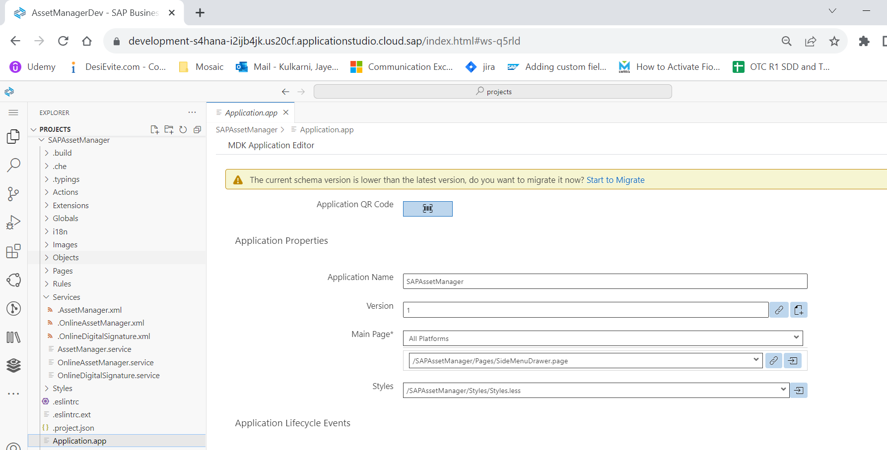

- Create a New MDK Empty Project “SAPAssetManagerExt” for CIM.
Add the reference of the Parent Application “SAPAssetManager” in “application.app” file.
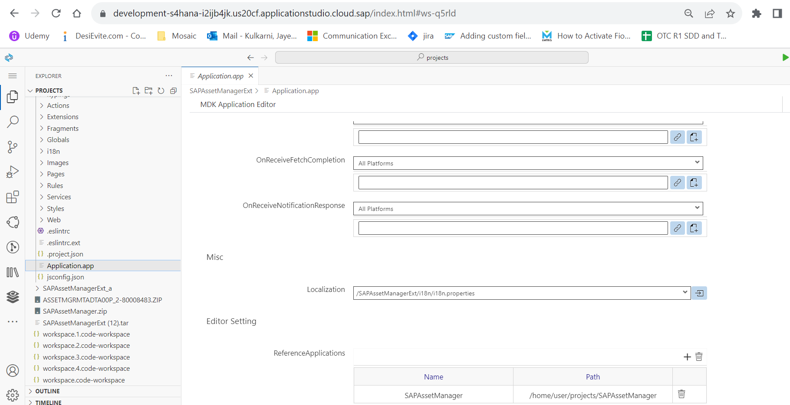

- Create the “CIM” (Component Integration Metadata) file in Parent application
SAPAssetManager.cim is created in Parent application. Name of the CIM should be same as project name of the component project.

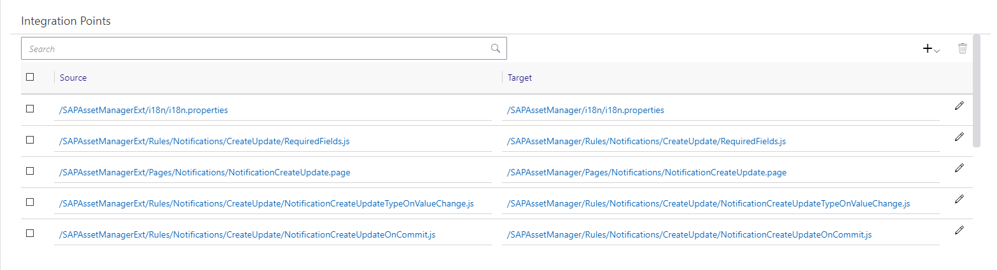
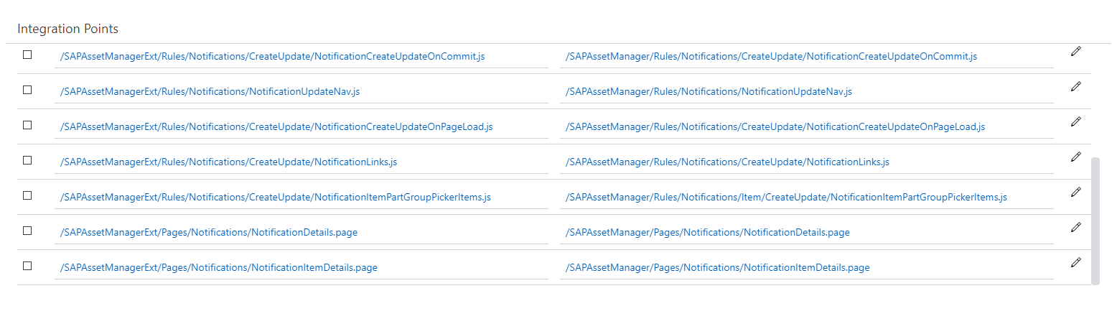
- Bases on the notification type, logic is written to show/hide fields in different rules like (NotificationCreateUpdateTypeOnValueChange, NotificationCreateUpdateOnPageLoad).
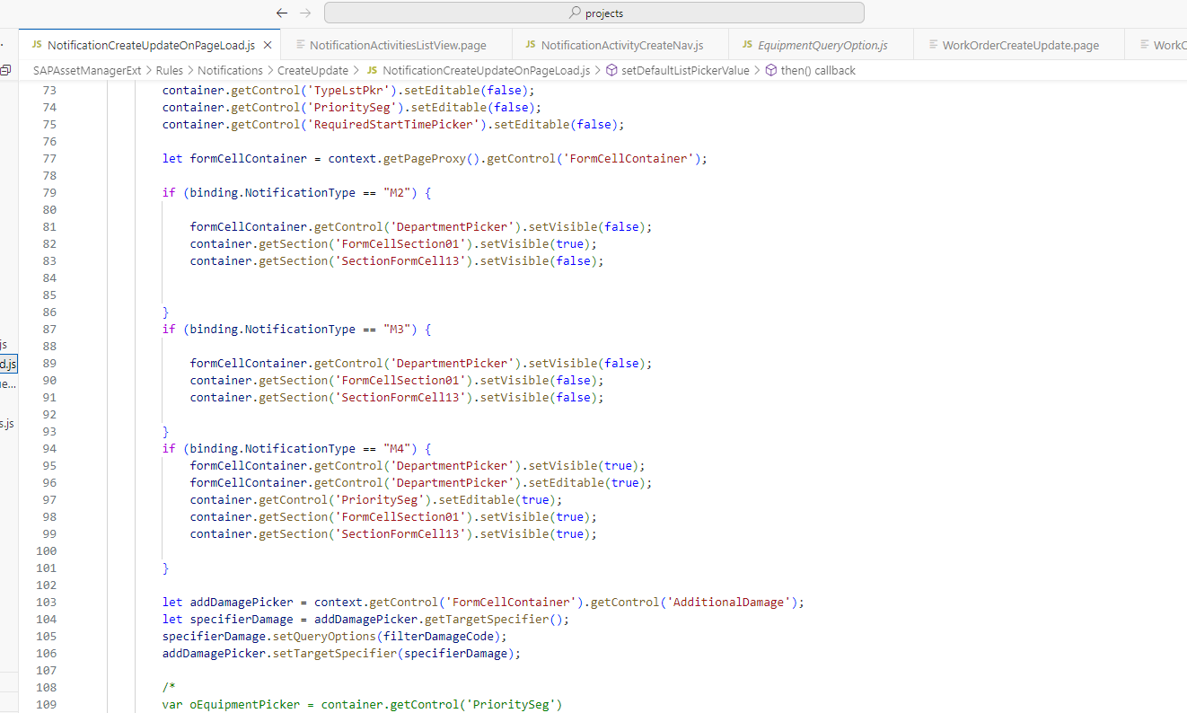

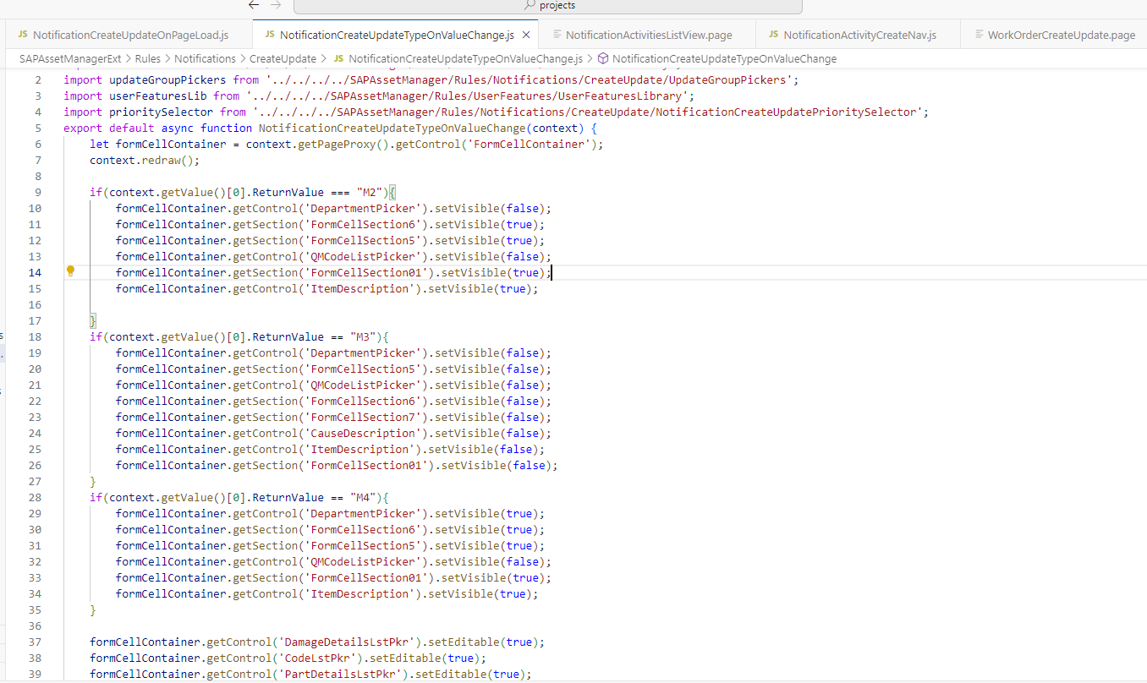

- For Each notification type, different fields are mandatory. Logic for same is written in RequiredField.js
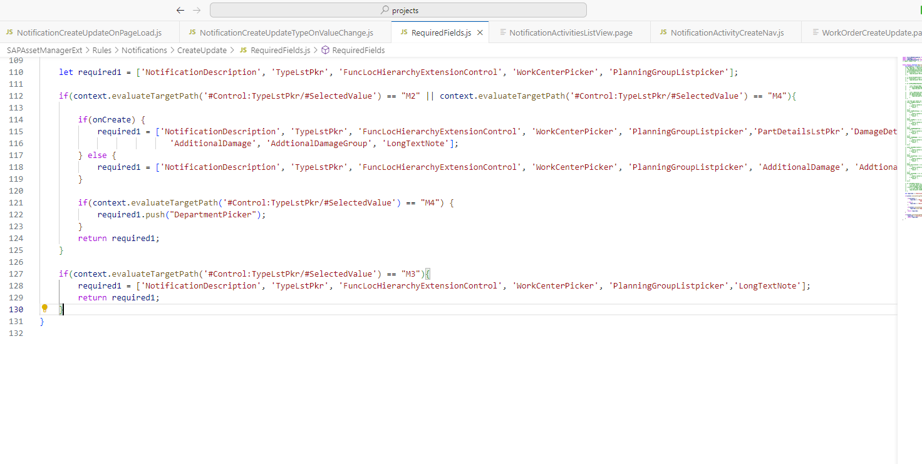

- Once changes are done, Navigate to Parent App (SapAssetManager) and right click on application.app and select MDK:Deploy and it will ask for login to cloud foundry
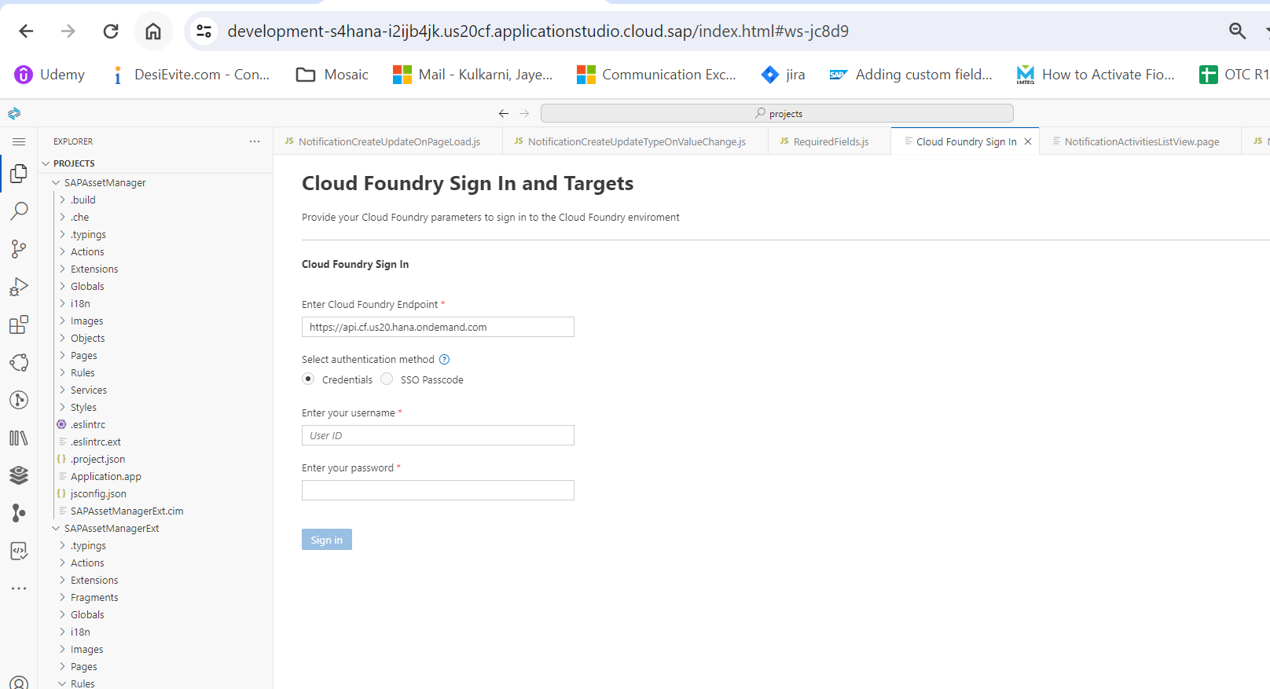

- Enter credentials and select org & space for deployment and then select the mobile service.
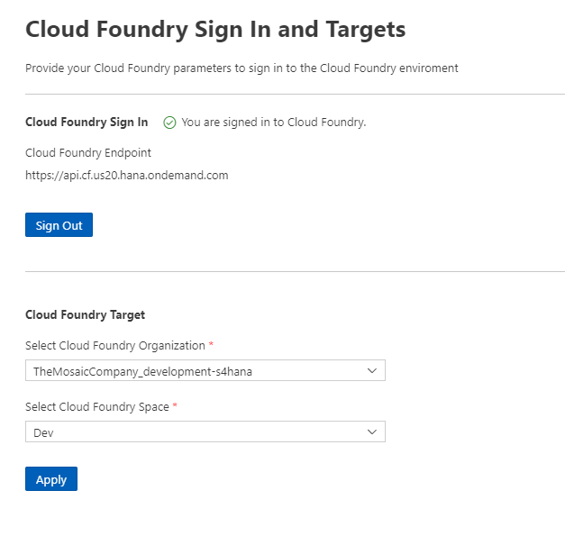
- Select Mobile Services and it will deploy the changes to selected mobile service.

